ATTRACTION TICKETS AVAILABLE FROM WELFARE.
£20.00 for a family of four. (2 adult + 2 Children)

Tickets cannot be reserved or booked over the telephone.

When you have planned your day out, you must email welfarearrc@hotmail.co.uk ,stating which day you would prefer and how many adults & children are going, tickets to the relevant day out are then collected on the morning from the guardroom & returned that evening before 22.00 hrs for re-use the following day.
The tickets are on first come first serve basis & we have limited number so book early to avoid disappointment, especially during stand down and public holidays as the tickets are very popular.

Cattle Country Noah’s Ark Farm Zoo
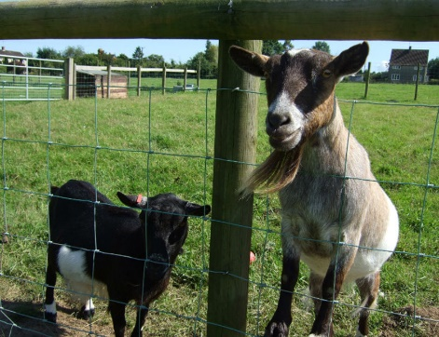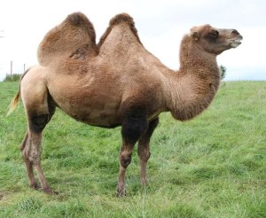

8 x individual tickets 2 x family tickets
Post Code GL13 9EW Post Code BS48 1PG

Slimbridge - £15.00 per family Bristol Zoo

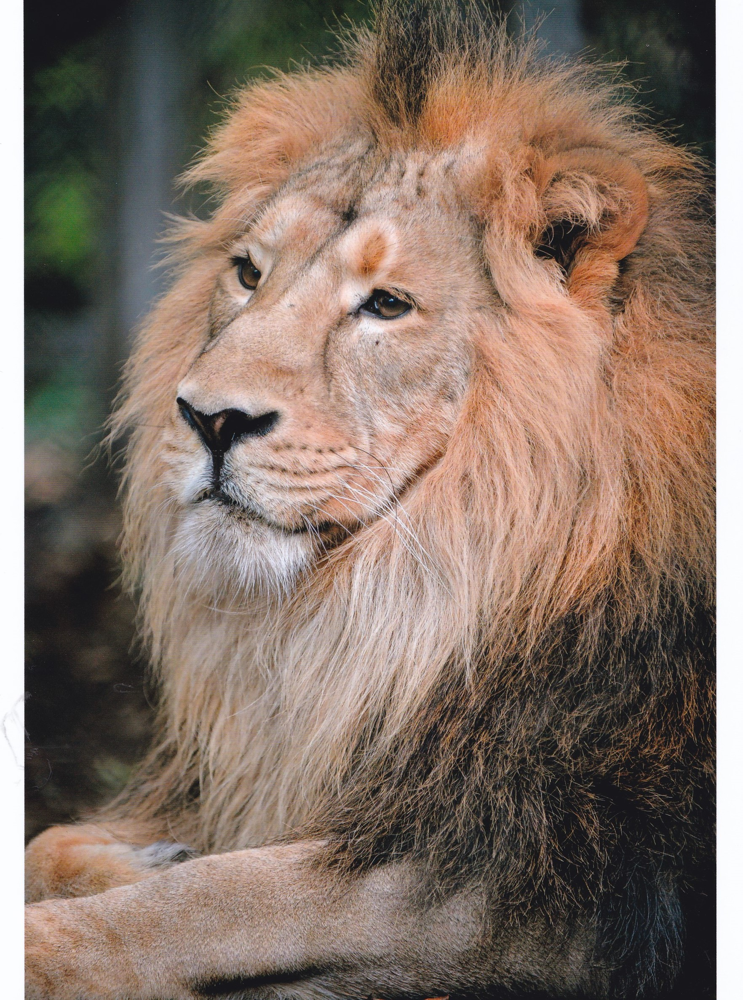

2 x family tickets ( 2 adults + 6 children) 8 x individual tickets
Post Code GL2 7BT Post Code BS8 3HA

Please be aware that the tickets are annual therefore the loss works out quite expensive, please secure the tickets while they are in your care.

Contact the Welfare Office on 01452 362550 for further information.

